Proxy link configured in UAT TMAC client app

Tetherfi_HttpProxy configured in Tmac Client

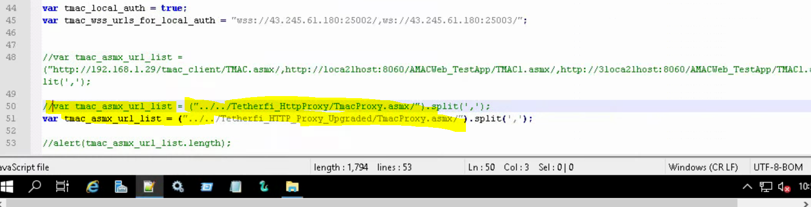

Old Proxy URL not able to browse .

https://w01sccvdapp1a.reg1.uat1bank.dbs.com/Tetherfi_HttpProxy/

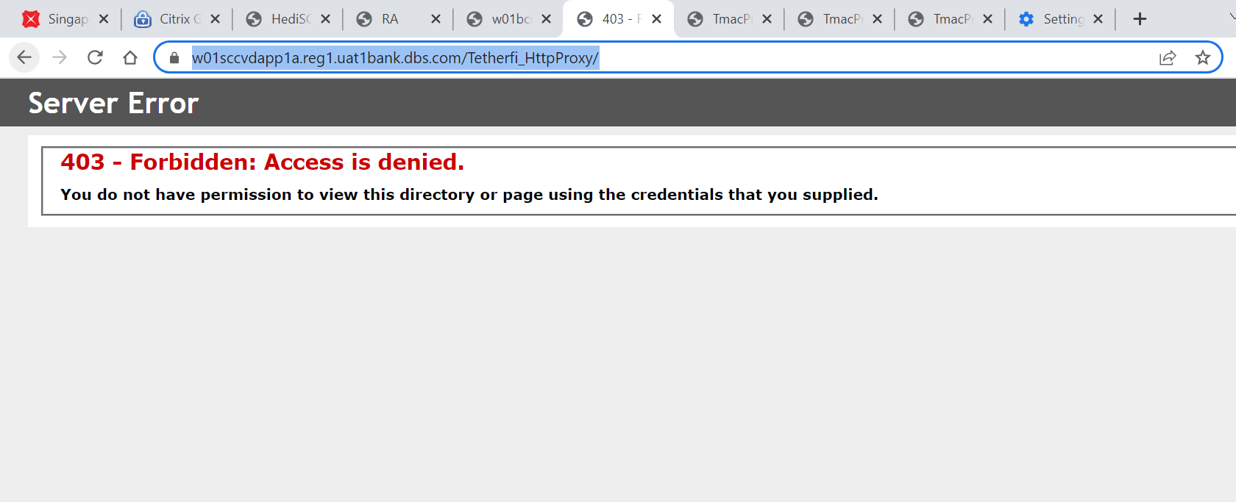

New proxy url

https://w01sccvdapp1a.reg1.uat1bank.dbs.com/Tetherfi_Http_proxy_upgraded/

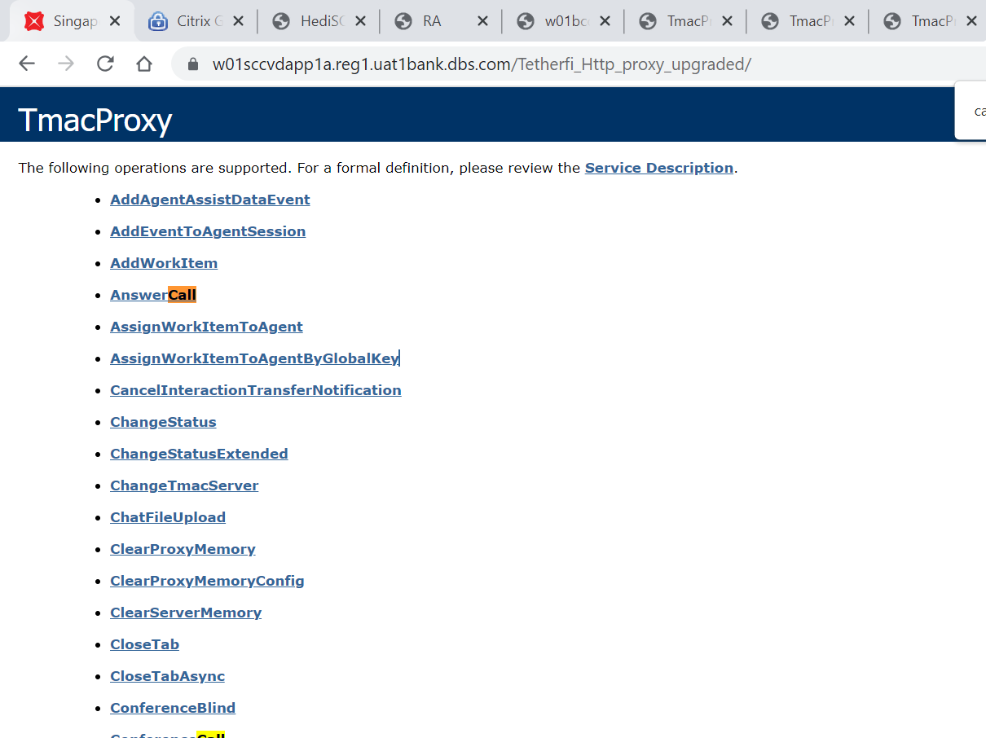

SIT WORKING LINKS

https://w01bccvdapp1a.reg1.uat1bank.dbs.com/Tetherfi_HttpProxy/

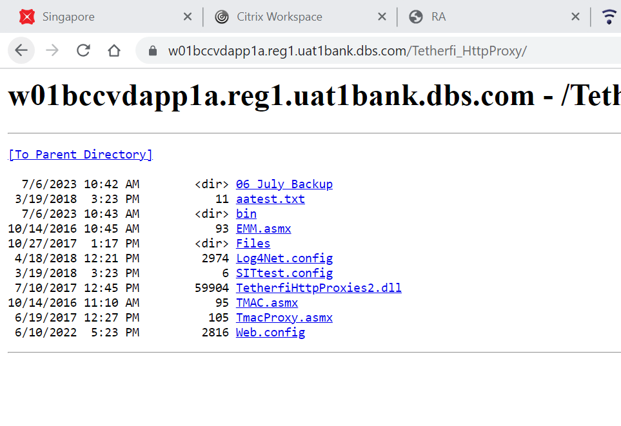

<https://w01bccvdapp1a.reg1.uat1bank.dbs.com/Tetherfi_Http_Proxy_Upgraded/>

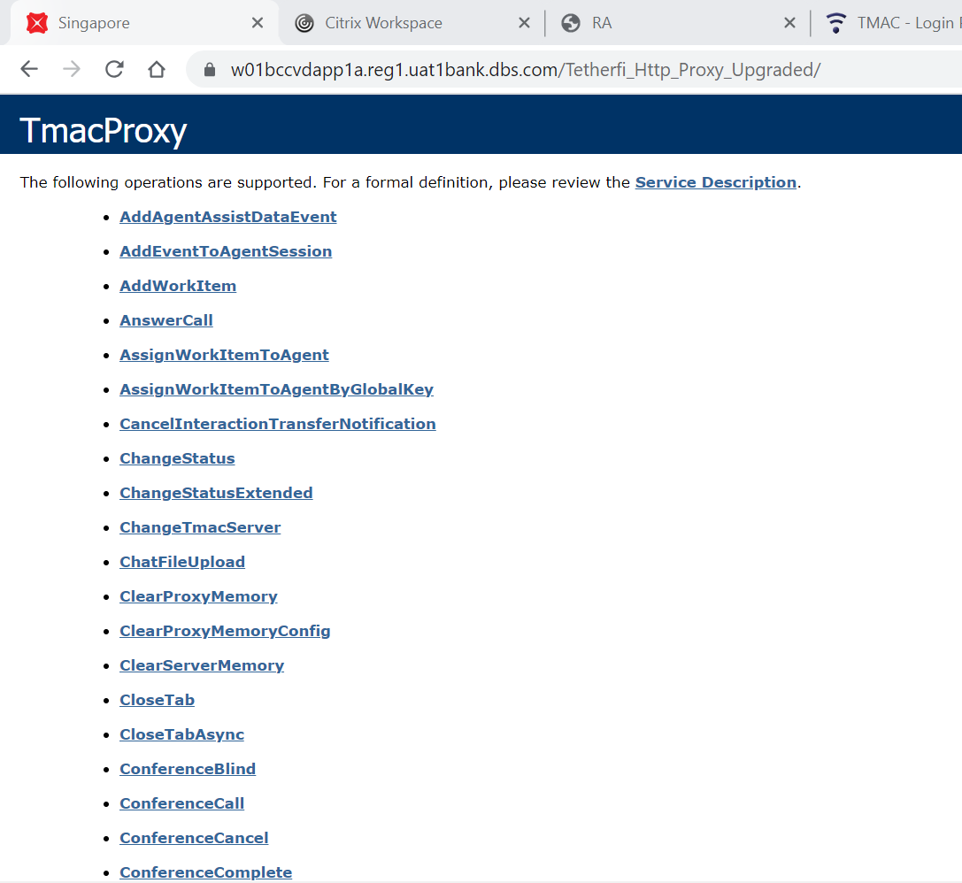

TEST LINKS configured in TESTAPP

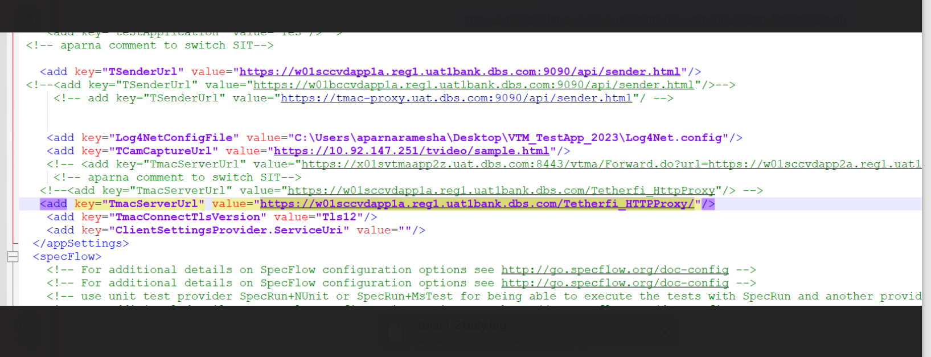

**Refresh apppool,** below screenshot is from SIT. Pool name might differ in UAT, please share screen while performing activity

